NAME :Harshrajsinh Zala

Reg :22BCE2238

JS EXERCISE 1

Q1 EVEN /ODD

CODE:

const prompt = require('prompt-sync')();

function chck(num) {

if (num % 2 === 0) {

return "Even";

} else {

return "Odd";

}

}

var n = prompt("Enter a number:");

var res = chck(parseInt(n));

console.log(res);

OUTPUT :

Q2 : RADIUS :

CODE :

const prompt = require('prompt-sync')()

function area(rad) {

return Math.PI \* rad \* rad;

}

let r = prompt("Enter the radius of the circle:");

let rad = parseFloat(r);

if (isNaN(rad) || rad <= 0) {

console.log("Please enter a positive number for the radius.");

} else {

let ar = area(rad);

console.log(ar);

}

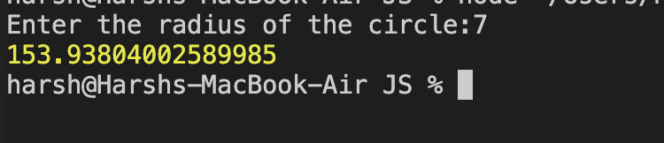

Q3 : Read year and check if the given year is a leap year.

CODE :

const prompt = require("prompt-sync")();

function isLeapYear(year) {

if ((year % 4 === 0 && year % 100 !== 0) || (year % 400 === 0)) {

return true;

} else {

return false;

}

}

let yearInput = prompt("Enter a year:");

let year = parseInt(yearInput);

if (isNaN(year)) {

console.log("Please enter a valid year.");

} else {

if (isLeapYear(year)) {

console.log(`${year} is a leap year.`);

} else {

console.log(`${year} is not a leap year.`);

}

}

OUTPUT :

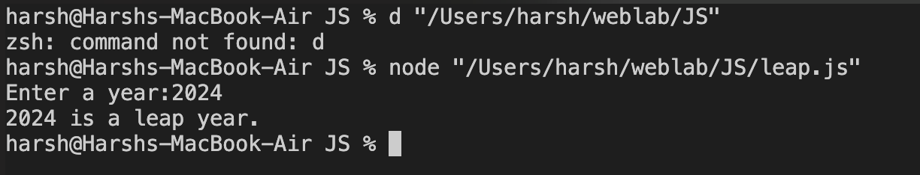

Q4 :

CODE :

const prompt = require('prompt-sync')()

let room = prompt("Enter room number:");

switch (room) {

case '823':

console.log("Java Programming");

break;

case '824':

console.log("Python Programming");

break;

default:

console.log("Invalid input");

break;

}

OUTPUT :

Q5 : MULTIPLICATION TABLE  
Code :

const prompt = require('prompt-sync')()

let n = prompt("Enter a number:");

n = parseInt(n);

if (isNaN(n)) {

console.log("Invalid n");

} else {

for (let i = 1; i <= 10; i++) {

let res = n \* i;

console.log((n)+"\* "+i+" = "+(n\*i))

}

}

OUTPUT :

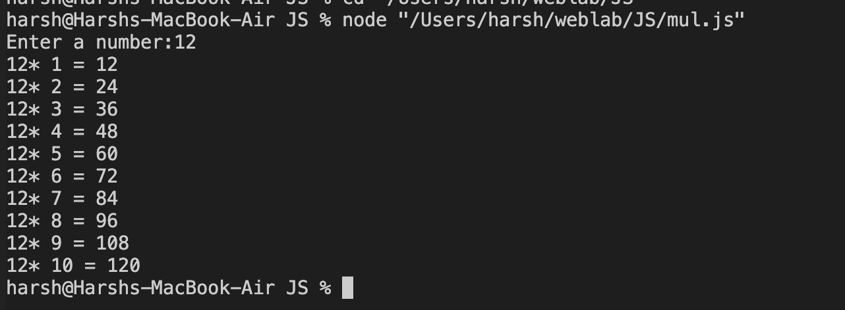

EXERCISE 2

Q1 :

Code:

const prompt = require('prompt-sync')()

let n1 = prompt("Enter the first integer:");

let n2 = prompt("Enter the second integer:");

let n3 = prompt("Enter the third integer:");

n1 = parseInt(n1);

n2 = parseInt(n2);

n3 = parseInt(n3);

let greater = n1;

if (n2 > greater) {

greater = n2;

}

if (n3 > greater) {

greater = n3;

}

console.log("the greatest among "+n1+","+n2+","+"and "+n3+" is: "+greater)

Output :

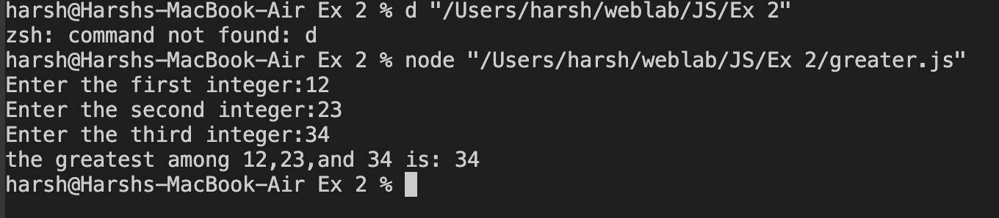

Q2 :

Code :

const prompt = require('prompt-sync')()

let mark = prompt("Enter the subject mark:");

mark = parseInt(mark);

if (isNaN(mark)) {

console.log("Invalid mark entry. Please enter a valid number.");

} else {

let grade;

if (mark < 40) {

grade = "F";

} else if (mark >= 40 && mark <= 60) {

grade = "E";

} else if (mark > 60 && mark <= 80) {

grade = "B";

} else if (mark > 80 && mark <= 90) {

grade = "A";

} else if (mark > 90 && mark <= 100) {

grade = "S";

} else {

grade = "Invalid inp";

}

console.log("Grade for the given mark" + mark + " is: " + grade);

}

OUTPUT:

Q3 :

Code:

const prompt = require('prompt-sync')()

let n = prompt("Enter a number between 1 and 3:");

switch (parseInt(n)) {

case 1:

console.log("one");

break;

case 2:

console.log("two");

break;

case 3:

console.log("three");

break;

default:

console.log("Wrong Input");

break;

}

Output :

Q4 :

CODE :

const prompt = require('prompt-sync')()

var country = prompt("Enter a country name:");

country = country.toLowerCase();

var capital;

switch (country) {

case "germany":

capital = "Berlin";

break;

case "uk":

capital = "London";

break;

case "pakistan":

capital = "Islamabad";

break;

default:

capital = "Wrong Input";

}

console.log("The capital of " + country.toUpperCase() + " is " + capital);

OUTPUT :

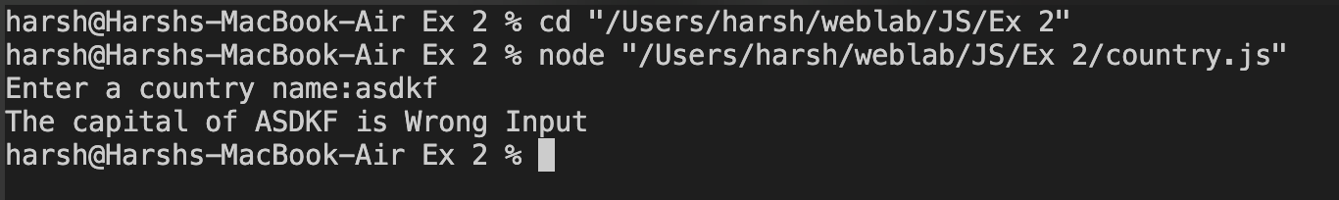

Q5:

CODE :

const prompt = require('prompt-sync')()

let ask = prompt("Enter the mark:")

let mark = parseFloat(ask);

let newMark = mark >= 40 ? mark + 10 : mark + 20;

console.log("New Mark: " + newMark);

OUTPUT :

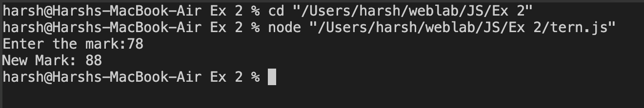

Q6 ;

CODE :

function isPrime(num) {

if (num <= 1) return false;

for (let i = 2; i <= Math.sqrt(num); i++) {

if (num % i === 0) return false;

}

return true;

}

function count(arr) {

let even = 0;

let odd = 0;

let prime = 0;

for (let n of arr) {

if (n % 2 === 0) {

even++;

} else {

odd++;

}

if (isPrime(n)) {

prime++;

}

}

console.log('Array:', arr);

console.log('Even numbers count:', even);

console.log('Odd numbers count:', odd);

console.log('Prime numbers count:', prime);

}

const arr = [2, 5, 8, 11, 15, 20, 23, 29, 30, 37];

// Call the function to count even, odd, and prime numbers

count(arr);

OUTPUT :

Q7 : ARMSTRONG

CODE :

const prompt = require('prompt-sync')()

function isArm(number) {

const str = String(number);

const totdigits = str.length;

let sum = 0;

for (let i = 0; i < totdigits; i++) {

const digit = parseInt(str[i], 10);

sum += Math.pow(digit, totdigits);

}

return sum === number;

}

const num = prompt("Enter the number");

if (isArm(num)) {

console.log(`${num} is an Armstrong number.`);

} else {

console.log(`${num} is not an Armstrong number.`);

}

OUTPUT :

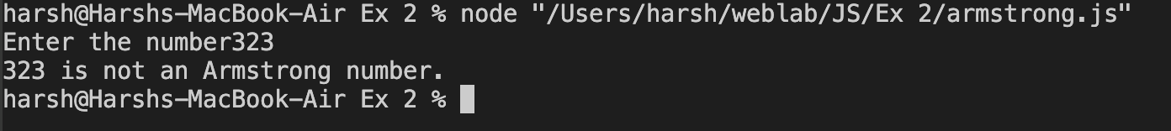

Q8 : sum of first n numbers

CODE :

const prompt = require('prompt-sync')()

function calsum(n) {

let sum = 0;

for (let i = 1; i <= n; i++) {

sum += i;

}

console.log("The sum of the first "+n+" numbers is: "+sum);

}

let n = prompt("Enter a number: ")

n = parseInt(n)

calsum(n);

OUTPUT :

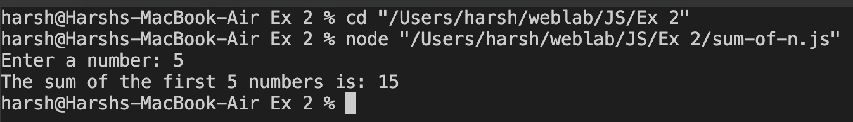

Q9 ;

CODE :

const prompt = require('prompt-sync')()

function isEven(num) {

return num % 2 === 0;

}

function isPrime(num) {

if (num <= 1) return false;

for (let i = 2; i <= Math.sqrt(num); i++) {

if (num % i === 0) return false;

}

return true;

}

function countdig(number) {

let even = 0;

let odd = 0;

let prime = 0;

let digits = number.toString();

for (let i = 0; i < digits.length; i++) {

const d = parseInt(digits[i]);

if (isEven(d)) {

even++;

} else {

odd++;

}

if (isPrime(d)) {

prime++;

}

}

console.log("Number of even digits: " + even);

console.log(":Number of odd digits: " + odd);

console.log("Number of prime digits: " + prime);

}

let n = prompt("Enter a number: ");

n = parseInt(n);

if (!isNaN(n)) {

countdig(n);

} else {

console.log("Invalid input. Please enter a valid number.");

}

OUTPUT :

Q10 :

CODE :

const prompt = require('prompt-sync')()

function rev(n) {

let revnum = 0;

while (n !== 0) {

const digit = n % 10;

revnum = revnum \* 10 + digit;

n = Math.floor(n / 10);

}

return revnum;

}

let n = prompt("Enter an integer: ");

n = parseInt(n);

if (!isNaN(n)) {

const res = rev(n);

console.log("Reverse of the digits: "+res);

} else {

console.log("Invalid input");

}

OUTPUT :

